Pack 5 Adult Leadership

Jason Golub
Chartered Organization Representative
Advent Associates, Pack 5

Scott Hedberg
Unit Commissioner

Pack 5 Committee
Tom Whitaker, Chair
Hans Masing, Co-Treasurer
Janet Deaton, Fundraising

Dell Deaton, Pack 5 Cubmaster
and Huron Trails District Vice-Chair

Marc Ammerlaan
Wolf Den Leader

Mike Arvidson
Bear Den Leader

Frank Oldani
Webelos II Den Leader
and Pack 5 Co-Treasurer

Sue Oldani
Webelos II Assistant Den Leader

Antoinette Prawdzik
Tiger Assistant Den Leader

Pete Prawdzik
Tiger Den Leader
and Webelos I Assistant Den Leader

Cathy Welch
Webelos I Den Leader

Webelos II Graduation
and Cross-Over Ceremony

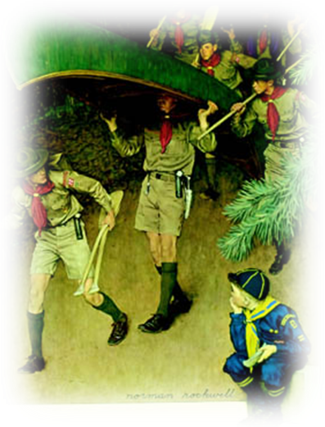

Pack 5 — Ann Arbor, Michigan

Sunday, March 2, 2008
Eberwhite Woods

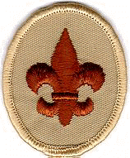

Program

Greeting and Pre-Program Webelos I Scouts

Opening Ceremony Webelos I Scouts

Welcome Cubmaster

Overview of Graduation and Cross-Over

New adventures: Joining a Boy Scout Troop!

Acknowledge Troop representatives Cubmaster

The path to Cross-Over for our 2008 Webelos II Den

Recognizing each Webelos II Scout and his family

Arrow of Light Awards Cubmaster

Symbolic candle lighting Webelos I Den

Graduation Certificates Cubmaster

Paving the way to the Cross-Over Bridge

Step 1 Tiger Den
Step 2 Wolf Den
Step 3 Bear Den
Step 4 Webelos I Den

Discarding the symbols of Cub Scouts

Individual Boy Calls to Cross-Over Troop Leaders

Congratulate new Boy Scouts!

Closing Ceremony Webelos I Scouts

Pack 5

Honors and Congratulations
its Graduating 2008 Webelos II Scouts

Max Cocco
Arrow of Light Award
Crossing to Boy Scout Troop 4

Sam Lewis
Arrow of Light Award
Crossing to Boy Scout Troop 4

Josh Lucas
Arrow of Light Award
Crossing to Boy Scout Troop 4

Tommy Oldani
Arrow of Light Award
Crossing to Boy Scout Troop 4

Avery Whitaker
Arrow of Light Award
Crossing to Boy Scout Troop 131



